H.T No
Regulations:
A20

Sreenidhi Institute of Science and Technology
(An Autonomous Institution)
Code No:8FC07 Date: 20-Aug-2024 (AN)

B.Tech III-Year I- Semester External Examination, August-2024 (Supplementary)
AUTOMATA THEORY AND COMPILER DESIGN (AIML)

Time: 3 Hours Max.Marks:70

Note: a) No additional answer sheets will be provided.
b) All sub-parts of a question must be answered at one place only, otherwise it will not be valued.
c) Missing data can be assumed suitably.

Bloom's Cognitive Levels of Learning (BCLL)

Remember | L1 | Apply | L3 | Evaluate | L5
Understand | L2 | Analyze | L4 | Create | L6

Part - A Max.Marks:20
Answer all QUESTIONS

 |  | BCLL | CO(s) | Marks
1 | Explain DFA with more than two outputs. | L2 | CO1 | [2M]
2 | List out various types in normal forms | L6 | CO2 | [2M]
3 | List different types of Turing Machine | L6 | CO3 | [2M]
4 | How to eliminate left recursion | L4 | CO4 | [2M]
5 | Define handle. Give suitable example? | L6 | CO5 | [2M]
6 | Construct triples of an expression: a *- (b + c). | L6 | CO6 | [2M]
7 | List and explain four components used to form a context free grammar | L6 | CO2 | [2M]
8 | Mention the ID format of a Turing Machine | L2 | CO3 | [2M]
9 | Discuss error recovery in LR parsing? | L1 | CO5 | [2M]
10 | Write a note on the specification of a simple type checker? | L1 | CO6 | [2M]
Part – B Max.Marks:50
ANSWER ANY FIVE QUESTIONS. EACH QUESTION CARRIES 10 MARKS.

 |  |  | BCLL | CO(s) | Marks
11. | a) | Construct DFA for given NFA.  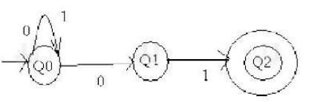 | L4 | CO1 | [5M]
 | b) | Minimize the given DFA  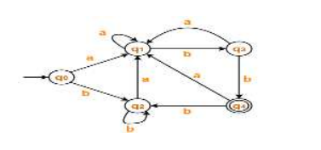 | L2 | CO1 | [5M]
12. | a) | Define regular grammar, left linear grammar and right linear grammar mention procedure for conversion with example. | L1 | CO2 | [5M]
 | b) | - Design CFG for L={an b n | n>=0}  - Let G be the grammar  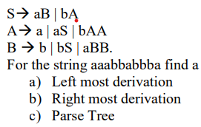 | L1 | CO2 | [5M]
13. | a) | Explain about Chomsky hierarchy of languages in detail. | L1 | CO3 | [5M]
 | b) | - Explain Church’s Turing Hypothesis?  - Design Turning Machine for L={wwr | w ϵ (0+1)* } | L1 | CO3 | [5M]
14. | a) | What are the rules for LL (1) grammar and check whether the given grammar is LL (1) or not for the following  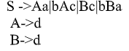 | L2 | CO4 | [5M]
 | b) | Explain Recursive Decent Parser with backtracking | L1 | CO4 | [5M]
15. | a) | Consider the grammar  E→ E + E|E *E|(E)| id  Show the sequence of moves made by the shift-reduce parser on the input id1+id2*id3 and determine whether the given string is accepted by the parser or not. | L1 | CO5 | [5M]
 | b) | Construct SLR parsing table for the following grammar  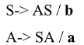 | L5 | CO5 | [5M]
16. | a) | Discuss how induction variables can be detected and eliminated from the given intermediate code  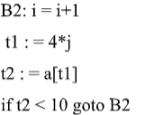 | L2 | CO6 | [5M]
 | b) | What are the advantages of DAG ? Explain the peephole optimization | L2 | CO6 | [5M]
17. | a) | Construct a DFA equivalent to the NFA, M=({q0,q1,q2},{0,1}, 𝛿,q0,q2) where 𝛿 is given by the following Transition diagram.  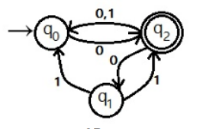 | L5 | CO1 | [4M]
 | b) | Convert the following CFG in to Chomsky Normal Form  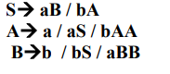 | L4 | CO2 | [3M]
 | c) | Design a PDA to accept the language | L1 | CO3 | [3M]
18. | a) | Define compiler? State various phases of a compiler and explain them in detail. And also Write down the output after each phase. For the following expression Position:=initial+ rate*60 | L1 | CO4 | [4M]
 | b) | Construct LALR parsing table for the following grammar  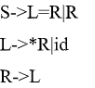 | L5 | CO5 | [3M]
 | c) | Explain the techniques used for loop optimization and Reduction in Strength. | L5 | CO6 | [3M]
-- 00 -- 00 –

